Class: Final Year B.Tech(Computer Science and Engineering)
Year: 2025-26 Semester: 1
Course: High Performance Computing Lab

Practical No. 2
PRN: 22510033
Name: Jasmine Imtiyaj Sayyad
Batch: B8
Title of practical: Study and implementation of basic OpenMP clauses
Implement following Programs using OpenMP with C:
- Vector Scalar Addition
- Calculation of value of Pi
Analyse the performance of your programs for different number of threads and Data size.

Problem Statement 1: Vector Scalar Addition
Screenshots:
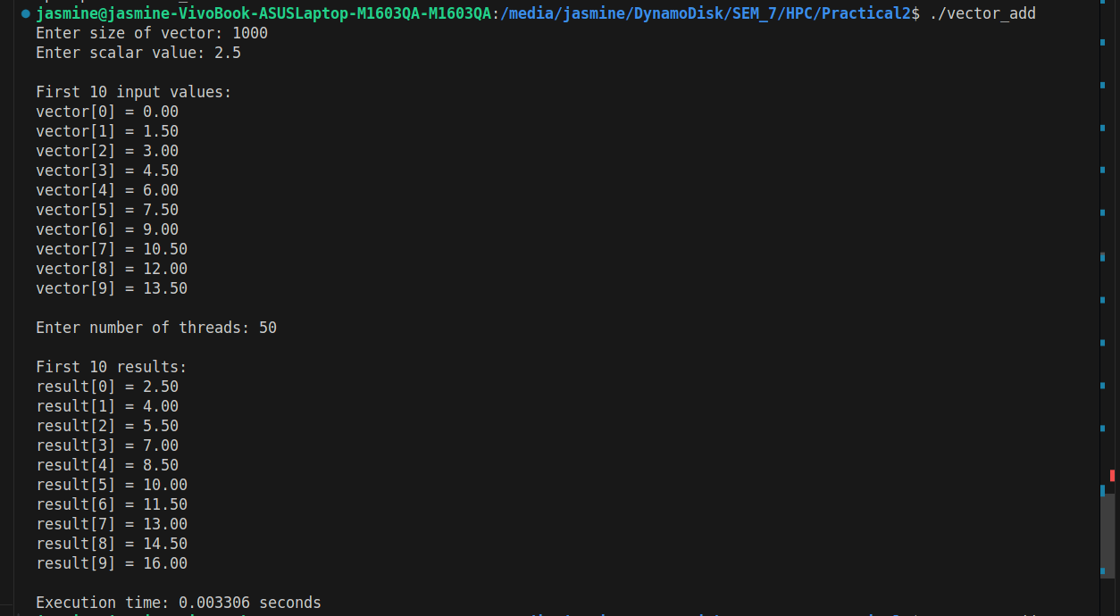
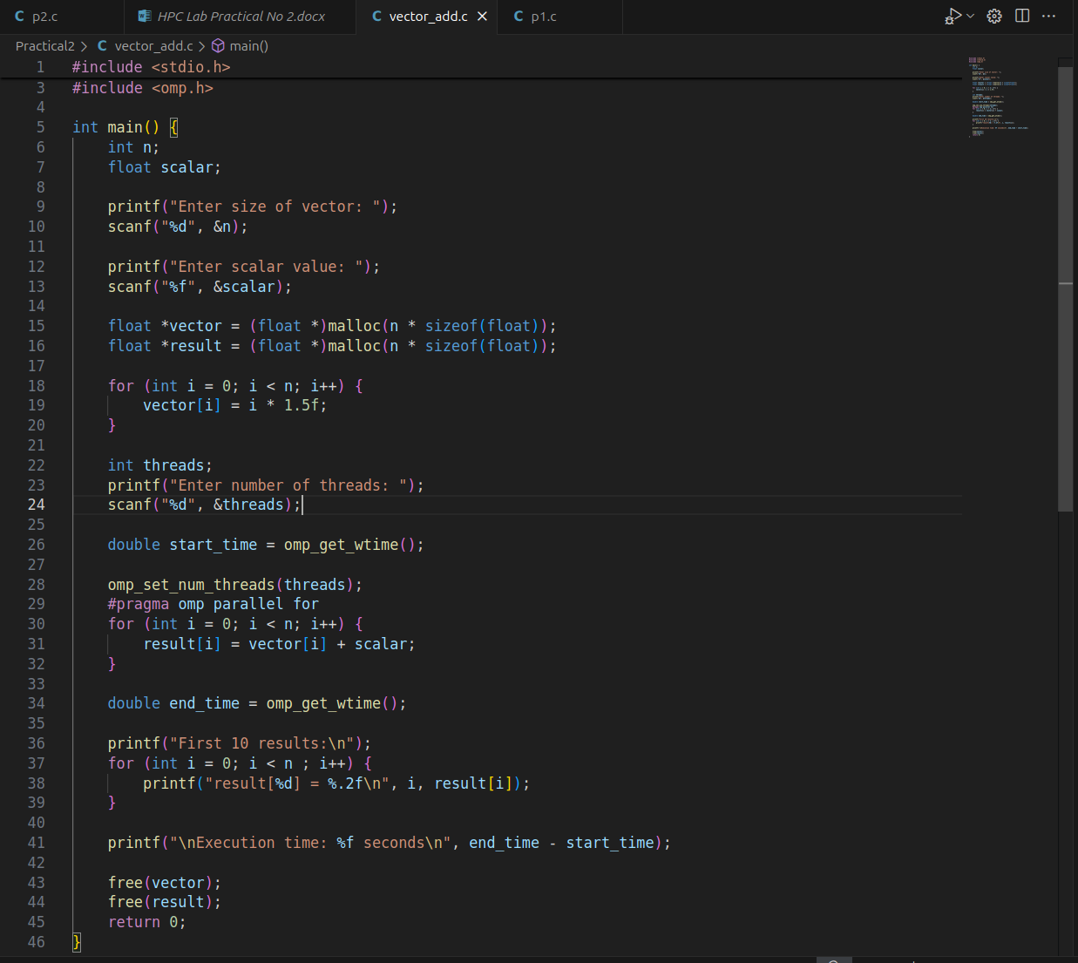
Information & Analysis:

OpenMP Basics Used in the Program

a) #pragma omp parallel for
- This directive parallelizes the for loop, distributing iterations across multiple threads.
- Each thread computes a portion of the loop iterations, improving performance for large vectors.

b) omp_set_num_threads(threads)
- Explicitly sets the number of threads to use.
- If more threads than available CPU cores are requested, OpenMP may limit actual thread usage.

c) omp_get_wtime()
- Used to measure clock time (real time taken for execution).
- Helps in comparing parallel vs. serial performance.

Problem Statement 2: Calculation of value of Pi

Screenshots:
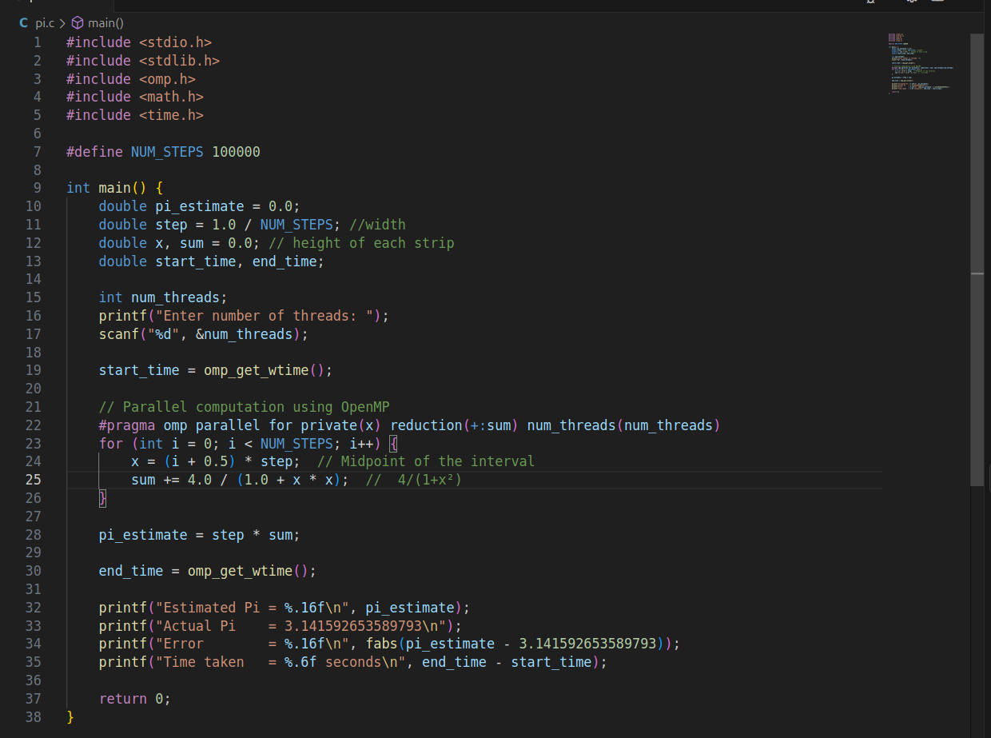

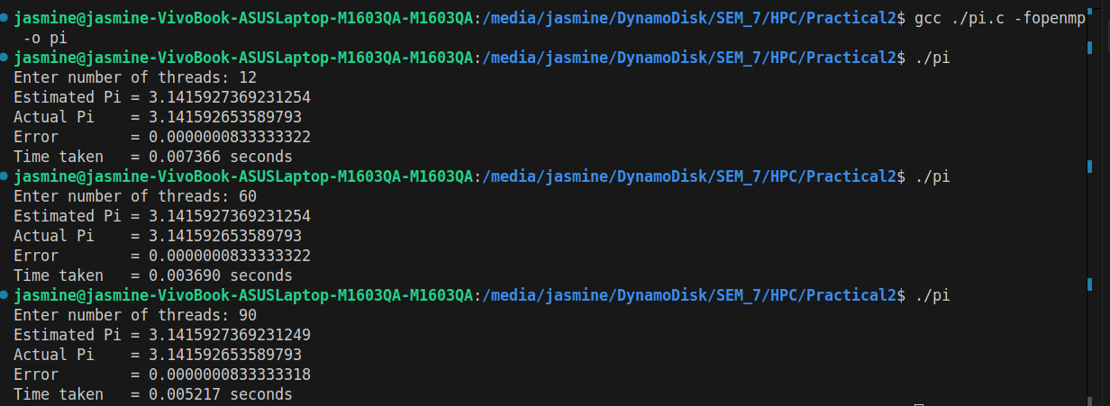
Information:

OpenMP Parallelization
#pragma omp parallel for: Splits the loop across multiple CPU threads for faster computation.
private(x): Each thread gets its own copy of x (no conflicts between threads).
reduction(+:sum): Combines partial sums from all threads safely (no race condition).
num_threads(num_threads): Sets the number of threads manually (user input).

Analysis:
How OpenMP Helps:
Parallelizes the loop (#pragma omp parallel for), splitting work across threads.
Uses reduction(+:sum) to safely combine results.
Thread Count Impact
Too few threads (1-2): Near-serial speed (minimal speedup).
Optimal threads (=CPU cores): Best performance.
Too many threads (>cores): Slower due to overhead (OS context switching).
Accuracy Depends on NUM_STEPS (more steps = better precision), not threads.
Github Link:
https://github.com/jasminesayyad29/HPC/tree/Practical2

